# Lecture 7: Regional availability and prospective source markets

Regional availability and prospective source markets

* Food balance sheets
* Informal cross border trade

*Readings*

* Food and agriculture organization (FAO). 2002. “Training in the Preparation of Food Balance Sheets: Food Balance Sheets: Applications and uses.” June-July. No. 6. FAO, Rome. <http://www.foodsec.org/DL/course/shortcourseFA/en/pdf/5_FBS_concepts.pdf>
* Famine Early Warning System (2006) “Informal Cross Border Food Trade in Southern Africa” November. - *In Public Folder* [www.fews.net/docs/Publications/1001210.pdf](http://www.fews.net/docs/Publications/1001210.pdf)

*Supplementary Readings*

* Tschirley, D. and A.M. del Castillo (2006) “Local and Regional Food Aid Procurement: An assessment of experience in African and elements of good donor practice.” Policy synthesis for cooperating USAID offices and countries missions No. 79. Washington: USAID. <http://ageconsearch.umn.edu/bitstream/54486/2/wp_27.pdf>
* East African Grains Council and Regional Agricultural Trade Intelligence Network. “East African Food & Trade Bulletin” (monthly publication) [www.ratin.net](http://www.ratin.net)

In the previous lecture, we examined how import parity prices shape traders’ incentives to move food into deficit countries. When import parity prices are above local market prices, the local market is segmented from the international market. Food may be available, and traders may be able to respond to increased demand. Assessing availability will help us to determine if this market segmentation is due to ample local surplus that is depressing local prices, or if administrative, financial, or logistical barriers are resulting in low prices with food scarcity. In the former case, local procurement options should be explored. In the latter case, regional procurement (rather than local procurement) may be preferred because procuring in areas without surplus and limited capacity to import more (either locally or regionally) will increase the likelihood that purchases will drive up prices, potentially harming local consumers. Therefore, consider availability in conjunction with trade policies, import parity prices, and trader constraints. Finally, we need to examine not just availability through formal channels, but also how availability may be supplemented or depleted through informal channels.

**Food balance sheets**

Food balance sheets (FBS) are estimates of local production, exports, consumption, and imports and can indicate surpluses within a country or regionally. FBS are often compiled at a national level. FBS are occasionally created for different agro-ecological zones within a country and may include other information on informal trade, feed, seed, livestock use, and processing and storage losses. FBS do not show how access to food may differ by subpopulation. The FBS may also include population and nutritional conversion factors, allowing for calculation of average per capita availability of calories, protein, and fats.

FBS were commonly used in the 1970s and 1980s, when food self-sufficiency was a common policy goal. Agricultural marketing boards set prices and/or bought surplus or released reserves depending on estimated production and utilization measures captured in FBS. With the increased reliance on trade to mop up surplus and to meet demand, FBS are less commonly used today.

The below table describes some common elements in food balance sheets.

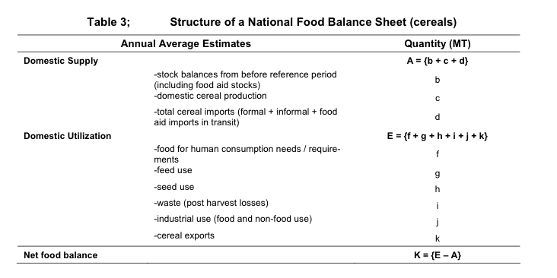

Source: WFP (2009) “The Basics of Market Analysis.”

*How does analyzing food balance sheets assist in answering the relevant MIFIRA sub-question?*

*2a. Where are viable prospective source markets?*

Non-surplus markets may be less suitable for procurement than surplus markets, unless traders are active importers and have incentives to import.

*2b. Will agency purchases drive up food prices excessively in source markets?*

Regions with available surplus face less risk of price increases due to agency procurement.

*To analyze a food balance sheet*

To assess availability from a balance sheet one must understand the assumptions used to generate the estimates and evaluate the likelihood of deviations from the past annual balance sheet (e.,g due to unanticipated production failures). Where possible, establish how each line was calculated. Note that values in an FBS should be treated as estimates. For example, maize loses weight as it dries (4% over 4 months following a harvest). This isn’t a “loss” that generally appears on the FBS but may be counted as such by farmers. If production and availability are highly volatile, it will be more difficult to predict whether local production can meet increases in demand due to local procurement.

FBS are often presented by commodity (or commodity group, such as cereals). One useful measure that can be derived from the FBS is the import dependency ratio (IDR), which is imports divided by the sum of production and net imports. This is a general calculation for key commodities, such as staples.

IDR= imports/ (production + imports – exports)

Governments may use the IDR to predict required imports, and may shift trade policies to encourage (or discourage) imports. The IDR can help elucidate the role of formal imports in meeting food availability. Note that the FBS does not always include estimates of informal imports. All else equal (i.e., import parity prices, trade policies, and exchange rates), countries regularly importing may be more able to boost imports in the face of additional demand more easily than countries that are sporadic importers. Similarly, regions or countries with large surplus or active trade may be better source markets for procurement.

It is also possible to compute a self-sufficiency ratio, which is the ratio of domestic production over total production and net imports. However, this measure can be misleading. A country that produces enough of a commodity to meet domestic needs may not do so, either because some of it is exported or because of unequal distribution or access.

*Malawi’s Cereal Balances for 2005*

The Malawi cereals FBS breaks down availability across a number of categories. Maize is clearly the dominant cereal produced and consumed in Malawi. Domestic supply is the sum of production, imports, and stocks minus exports (in red below). In this example, domestic supply is equivalent to domestic utilization, which is the sum of feed, seed, processing and food (in blue below). Note that reported imports of maize are 125,000 metric tons.

According to this FBS, 1.2 million tons were produced, 2.1 million tons were available (sum of production, imports, and stock variation) and about 1.9 million tons were required. The stock variation is changes in stocks occurring during the reference period at all levels between the production and the retail levels, i.e. it comprises changes in government stocks, in stocks with manufacturers, importers, exporters, other wholesale and retail merchants, transport and storage enterprises and in stocks on farms. In actual fact, however, the information available often relates only to stocks held by governments and even these are not available for a number of countries and important commodities. In the absence of information on opening and closing stocks changes in stocks are also used for shifting production from the calendar year in which it is harvested to the year in which it is consumed. Net increases in stocks (add to stock) are generally indicated by the sign "-". No sign denotes net decreases (from stock).

If we were to use this FBS, we would want to examine roots and tubers, which are important substitutes for cereals in Malawi. Further, this balance sheet does not include waste. The total domestic utilization (sum of feed, seed, processing and food) is below the domestic supply quantity.

|  |  |  |  |  |  |  |  |  |  |  |
| --- | --- | --- | --- | --- | --- | --- | --- | --- | --- | --- |
| Item | **Production (1000 tons)** | **Import Quantity (1000 tons)** | **Stock Variation (1000 tons)** | **Export Quantity (1000 tons)** | **Domestic supply quantity (1000 tons)** | **Feed (1000 tons)** | **Seed (1000 tons)** | **Processing (1000 tons)** | **Food (1000 tons)** | **Domestic consumption quantity (1000 tons)** |
| Cereals –  Excluding Beer + | 1289 | 189 | 725 | 3 | **2199** | 152 | 40 | 32 | 1813 | 2038 |
| Wheat | 2 | 41 | 0 | 2 | 40 | 0 | 0 | 0 | 39 | 39 |
| Rice  (Milled Equivalent) | 28 | 1 | 0 | 0 | 29 | 0 | 1 | 0 | 27 | 28 |
| Barley | 0 | 6 | 0 | 0 | 6 | 0 | 0 | 6 | 0 | 0 |
| Maize | 1225 | 125 | 725 | 0 | **2074** | 150 | 38 | 12 | 1718 | 1918 |
| Millet | 16 | 0 | 0 | 0 | 16 | 1 | 1 | 0 | 15 | 17 |
| Sorghum | 18 | 16 | 0 | 0 | 34 | 2 | 1 | 14 | 14 | 31 |
| Cereals, Other | 0 | 0 | 0 | 0 | 0 | 0 | 0 | 0 | 0 | 0 |

Source: FAO Food Balance Sheets: <http://faostat.fao.org/site/368/default.aspx#ancor>

In 2005, Malawi experienced a poor harvest and a drought, culminating in a hungry season during December 2005-March 2006. The government of Malawi had promised fertilizer subsidies for 2004 maize planting but didn’t deliver them in time. Traders, given the government announcement of subsidies, waited to import fertilizer. The lack of inputs resulted in low yields, which was compounded by drought. The government released reserves at a fixed price, but with non-government prices climbing, the reserves were rationed. The government intended to import 60,000 tons of maize as a stop gap, but it was too little to stop the rapidly increasing prices. During the summer and fall of 2005, prices doubled. Domestic food prices began to approach import parity prices, before briefly exceeding them. While the FBS indicates a need for imports, prices remained below import parity, suggesting that for many traders it made little sense to import for much of the year. Indeed, given that the government was releasing reserves and therefore keeping prices low, traders would have been reluctant to import food. This highlights a limitation of the FBS. Food balance sheets are not linked to prices, are often static, and do not reflect current policy environment. In Malawi, the FBS indicated a domestic shortfall but with IPP above domestic prices, it seems likely that many traders did not import food, fueling further concerns about shortages.

*Maize prices versus import parity in Lilonge Malawi*

Source: “Improving the Performance of Staple Markets to Exploit the Productive Potential of Smallholder Agriculture” by T. S. Jayne, A. Chapoto, and B. Shiferaw

AGRA Conference on “Towards Priority Action for Market Development for African Farmers,” Nairobi, Kenya, May 13-15, 2009

*2008 East Africa Regional Maize Availability*

More regionally aggregated FBS can provide snapshots of areas with large starting stocks, production and consumption, as well as indicate trading partners. Large volumes traded between countries over multiple years likely indicate relatively strong options for prospective source markets.

*Estimated East Africa maize availability balance sheet (July 2008 to June 2009) for minimum quality maize*

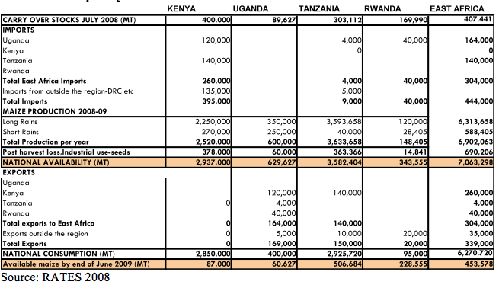

In this example, the regional food balance sheets indicate that several countries could be sources for regional procurement, depending on prices. During this period, Uganda and Tanzania were major net exporters of maize to other countries in East Africa (primarily Kenya) and to outside the region. Rwanda exported some maize, but imported more from Uganda. Thus, Uganda and Tanzania, in 2008-2009, would be potential sources for regional procurement of food aid. This helps answer MIFIRA questions 2a (Where are viable prospective source markets?) and 2b (Will agency purchases drive up food prices excessively in source markets?).

*Limitations of food balance sheets*

There are a number of limitations associated with FBS.

* FBS are based on estimates and any FBS is only as good as the underlying estimates. Some estimates are less reliable than others. For example, roots and tubers production estimates are generally much weaker than maize production estimates. Similarly, there may be a larger margin of error associated with losses due to processing and waste than due to seed requirements.
* FBS are not linked to prices, are often static and are available only after a significant lag (typically at least one year).
* Donovan et al. (2005) reports that governments may use FBS estimates to advocate for aid, and often there can be a large gap between official FBS estimates and other methods of estimating supply.
* Generally, FBS do not take into account for informal trading, which is often endogenous (i.e., informal imports may increase to reflect domestic production failures).
* FBS also do not examine what happens to the staple food gap when the staple price changes. Dorosh et al. (2006) argue that if estimates of staple supply do not adjust in the face of increased staple prices, the FBS will overstate food gaps by not recognizing that consumers will switch from the more expensive staple to substitutes.
* The FBS can be a useful starting point for understanding availability but will need to be complemented with information on import parity prices, harvest predictions, non-price trader constraints, and food policies that may shift production, consumption, or trade of commodities. This is particularly true for any new policies implemented since the most recently available FBS.
* FBS may be a political document without very firm statistical foundations. Discretely ask experienced users of the country’s agricultural statistics about the reliability of the FBS to help inform your assessment of its reliability.

There are also a number of responses to FBS limitations. First, understand how each line item was estimated, and whether there are associated confidence bands around the estimates (e.g., the amount used for feed could be off by 5%). Discussions with major importers, wholesalers, or other key informants can help verify estimates, especially with respect to trade and can also help to identify how governments use the FBS.

In response the shortcomings of FBS, ODAN – WFP (2007) recommends using FBS to examine changes, but not levels. One would then need to collect multi-year FBS figures and, when feasible, examine major commodities and their substitutes. For example, if maize is the preferred good, but households also consume sorghum when maize prices increase, consider combined maize and sorghum availability.

Lastly, adjust the FBS to include informal trading, which is discussed further below.

*Sources of information on food balance sheets*

* FAO regularly assesses 20-25 countries with the intent of providing information on imminent food security problems. CFSAM assessments are commonly the most up-to-date and reliable source of food supply information, which is especially important for assessing question 2a but also helpful with 1c.
* Bureaus of Agriculture or Statistics may also make annual FBS available or can provide information on the agricultural sector in the national economy, including:
  + Size/share of the sector
  + Employment and livelihood dependence on the sector
  + Export contributions of agriculture
  + Agricultural and economic policy changes
  + Crop production and food supply assessment
* Food balance sheets, if based on the previous year, should be updated with production predictions. Information on production can be obtained from Global Information and Early Warning System on food and agriculture (GIEWS: <http://www.fao.org/GIEWS/english/index.htm>). GIEWS provides various early warning indicators by region. While not all indicators are available for all regions, possible indicators include: crop prospects and the food situation; satellite imagery of vegetation for all regions; cereal supply and demand balances; and, a list of low-income food deficit countries.

**Informal cross border trade**

Formal trade is subject to a variety of controls and regulations, which lead some traders to use informal trade channels to circumvent such controls (e.g., import or export bans, sanitary and phytosanitary standards, tariffs, fluidity of borders, trader capacity, and seasonality). For particular countries, informal trade volumes can be quite large. Some informal trade is “quasi-legal”, such as small traders regularly crossing borders unofficially to conduct small volume trade. Other informal trade, sometimes called “technical” smuggling, employs explicitly illegal actions such as under-invoicing and bribery of customs officials. Technical smuggling can involve large volumes.

*How does analyzing informal cross border trade assist in answering the relevant MIFIRA sub-question?*

Studying informal trade patterns offers a useful check on official FBS data. Including rough estimates of the size and net flow of informal trade is useful for determining whether particular countries could be suitable sites for local procurement. Where informal trade is a sizeable component of trade, the validity of FBS may be in doubt.

*How to compute / estimate informal cross border trade*

In places with active informal cross border trading and parallel markets operating, compute flows and incorporate them into food balance sheets, particularly if production estimates only include flows in “official” channels. Key informant interviews with informal traders or individuals knowledgeable about informal trade (e.g., government ministers or larger regional traders who may interact with informal traders) may be able to provide approximate trade volumes and trader characteristics.

If informal cross border trade appears to be an important source of supply for the local markets of interest but there are no estimates of informal trade volumes, consider spending a day counting informal trade across a key border crossing, and asking a sample of informal traders about their volumes as they cross (identify key days for informal trade at particular crossings, which may reflect local market days). Aggregate volume by location (e.g., border crossing).

FAO/GIEWS (1996) recommends assessing the opinions of receiving market traders about the order of magnitude of unrecorded cross border trade and sampling popular border crossings (counting the number and tonnage of trucks carrying cereals). Also, collect information on the types and numbers of traders engaging in informal trade and any constraints faced by them. If possible, collect prices on both sides of the borders to compute informal import parity prices. The average of the sample multiplied by the number of informal traders moving across the border can provide a rough estimate of the volume of trade at this border, for the season during which the trade is occurring.

In a few instances, monitoring projects may exist. The best example of regular, careful monitoring of cross border trade is the FEWS NET / WFP / FAO southern Africa Informal Cross Border Trade project. Below is a map indicating sites where informal trade is monitored.

*FEWS NET Informal Trade Monitoring Sites* 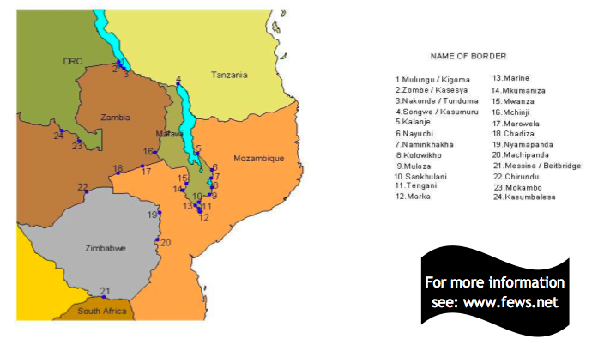

Source: FEWS NET 2006 “Informal Cross Border Food Trade in Southern Africa” Vol 26.

The volumes captured from these sites can be quite substantial. FEWS NET’s capture of maize trade in southern Africa allows us to update Malawi’s FBS. The above FAO estimate of imports into Malawi in 2005 was 125,000 metric tons. FEWS NET’s quarterly data aggregated across 2005 shows that, net, at least 121,000 metric tons of maize flowed informally into Malawi for 2005, almost equivalent to the amount of formal imports. This estimate includes only maize imported through border crossings with monitoring sites. While no scale-up is available for sites missed, it does indicate that a sizable volume of food moved into Malawi.

Incorporating informal trade into Malawi substantially increases Malawi’s domestic maize availability and suggests that reliance on FBS alone will overstate Malawi’s domestic availability shortfall.

**Net informal cross border imports into Malawi in 2005**

|  |  |  |  |  |  |
| --- | --- | --- | --- | --- | --- |
|  | **Jan-Mar** | **Apr-Jun** | **Jul-Sep** | **Oct-Dec** | **Total** |
| **Imports to Malawi** |  |  |  |  |  |
| Mozambique to Malawi | 17,438 | 29,064 | 26,866 | 8981 | 82,349 |
| Tanzania to Malawi | 2395 | 471 | 1211 | 33,601 | 37,678 |
| Zambia to Malawi | 760 | 34 | 36 | 349 | 1179 |
| **Exports from Malawi** |  |  |  |  |  |
| Malawi to Mozambique | 0 | 0 | 0 | 0 | 0 |
| Malawi to Tanzania | 96 | 103 | 174 | 358 | 731 |
| Malawi to Zambia | 15 | 8 | 5 | 31 | 59 |
| **Net imports** |  |  |  |  | **120,416** |

Source: FEWS NET 2006 “Informal Cross Border Food Trade in Southern Africa” Vol 26.

Returning to the 2005 maize balance sheet for Malawi, the gap between the amount consumed (1.9 million tons), and the amount produced (1.2 million tons) and formal and informal imports (245,000 tons) shrinks to about 480,000 metric tons. Yet, the stock variation listed on the FBS is 725,000, suggesting that the government of Malawi may have released more reserves from their stock than they needed.

*Limitations of the analytic*

Informal trade is highly sensitive to seasonality; therefore estimates found in one season should not be assumed to apply across the entire year. Also, it is time-intensive to count trade across numerous borders for larger samples.